STORYTELLER THE KIOSK

İdil Çalışkan

K3 - wenn Künstler Kunst kuratieren (1/3)
Naomi Tereza Salmon
15.02.2009

ABSTRACT

Have you ever thought about the journey of the ‘kiosk’ that you buy your newspaper everyday? In many European languages newspaper seller huts called kiosk. According to the German, French and English etymology dictionaries kiosk was an earned Turkish word to those languages- first to French and subsequently to German and English in 15th or 16th century. Actually it was an identical word both in Persian and Turkish. However the meaning was slightly different than nowadays.

"palace, portico" from Pers. kuşk ( kushk)
"pavilion, palace," from Turk. köşk(koshk)
"open pavilion," from Fr. kiosque, (1625)
Modern sense influenced by Brit. telephone kiosk (1928)

The interesting thing is that, kiosk was used for the big mensions in the past as it was koshk (kushk) in Turkish. It is used in the meaning of, chair, balcony, consoled room as well but not in the meaning of kiosk. However recently a slightly different word appeared in Turkish as well as in the European languages, kiosk, though there was already a Turkish word for this spatial structure( i.e. tr. büfe) . Thus, there are two different words for the etymologcially same word actually. How did the name of the big mansions changed its meaning into a small hut and evolved to a space many interesting events could take place then? Consequently, there is not only etymologic history of kiosk to be told but also an architectural background.

REVIEW OF LITERATURE

Kiosk: originally in Islamic architecture, an open circular pavilion consisting of a roof supported by pillars. The word has been applied to a wide variety of architectural elements:

- The summer palaces of the sultans of Turkey were called kiosks. A type of early Persian mosque, having a domed central area, is known as the kiosk mosque.(Britannica encyclopedia)
- Oriental summer-palace or pavilion for temporary resort.
- Small open or partly open free-standing structure, the roof (often tent-like) carried on posts or a light colonnade, used as a garden-pavilion, band-stand, or summer-house, often with an oriental character, in the Moorish, Hindu, or other exotic style.
- Public telephone-box or a small stall for the sale of newspapers, etc.

However the sense lies beneath this etymologic evolution might be a spatial fact from Islamic architecture as well.

Kiosk mosque:

In the Seljuk Architecture, in the 13th century, many http://www.geocities.com/felsefe_ekibi/grafik/Gesu.jpgkhans (i.e. inn with a large courtyard or caravansarai) used to be built in order to serve accommodation for the merchant passengers (caravans) of the Silk Road. Those khans were built with thick walls in case of any kind of attacks. So that khans were safe places for the passengers and the merchants. There used to be a khan in every 30-40 km of way, which is one day camel trek. In general there exists a large open courtyard and a closed hall. In the ones called Sultan khan, there exists a kiosk mosque (i.e. masjid) in the center of the courtyard. This architectural element, symbolizing the sultan and was not used by the other residents of the khan, was the most important part of the khan. The mosque of the khan is a free-standing structure in the middle of the courtyard. It is supported by four big arches and contains a mihrab on the inside. The mosque is approached by a set of steps to the south side.

The power and elegance of the decoration of this kiosk mosque rivals that of the portal, and is worthy of the sultan who probably worshipped here. The mosque was raised to separate it from the hubbub of animals and goods below, to create a clean place for worship.
Kiosk mosque is a structure that looks like the recent kiosks. (figure 1,2)

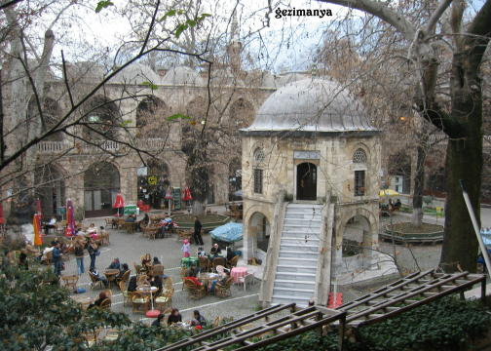
Koza Khan, Bursa, Turkey (figure 1)
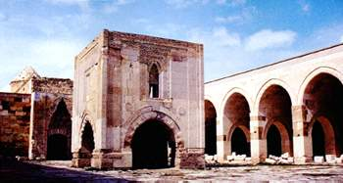
Agizkara Khan, Nevsehir, Turkey (figure 2)

Peker states that:
The masjid of the caravanserai is at the centre of the courtyard. It leans on four big arches and contains a mihrab on the inside. It is because a caravanserai is a profane and a very functional building; so-called kiosk-masjid is heightened from the ground to create a space devoted to the house of God. Stables and rooms, which were covering daily services like medication, game, nourishment and assembly, are placed around the courtyard. Barrel vaults cover all these rectangular units. The portal of the enclosed section fronts the masjid in the courtyard. Behind it, is the huge hall of the sleeping and living grounds. (2001)
Kiosks mosques are only historical ruins now and are not used. However, for the visitors of the caravansarais are always attracted by the small structures standing in the middle of the courtyard.

On the other hand, there might be another history of kiosks. The kiosk may be defined as an open summer-house or pavilion usually having its roof supported by pillars with screened or totally open walls. As a building type it was first introduced by the Seljuks as a small building attached to the main mosque, which consisted of a domed hall with open arched sides. This architectural concept gradually evolved into a small yet grand residence used by Ottoman sultans, the most famous examples of which are quite possibly the Tiled Kiosk (tr. Çinili Köşk) (figure 3) and Baghdad Kiosk (tr. Bağdat Köşkü) (figure 4). The former was built in 1473 by Mehmed II ("the Conqueror") at the Topkapı Palace, Istanbul, and consists of a two storey building topped with a dome and having open sides overlooking the gardens of the palace. The Baghdad Koshk was also built at the Topkapı Palace in 1638-39, by Sultan Murad IV. The building is again domed, offering direct views onto the gardens and park of the Palace as well as the architecture of the city of Istanbul.
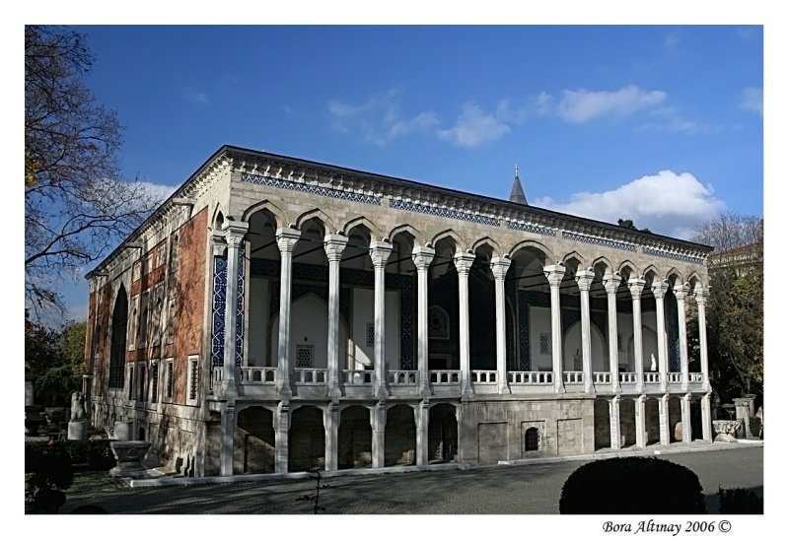
Tiled Kiosk, Istanbul, Turkey (figure 3)
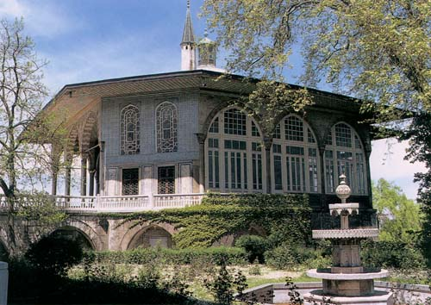
Bagdat Kiosk, Istanbul, Turkey (figure, 4)

Sultan Ahmed III (1703-1730) also built a glass room of the Sofa Kiosk (figure 5) at the Topkapı Palace incorporating some Western elements, such as the gilded brazier designed by the elder John Claude Duplessis which was given to the Ottoman Ambassador by King Louis XV of France.
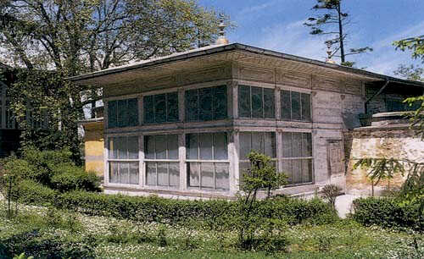
Sofa Kiosk, Istanbul,Turkey (figure 5)

The first English contact with Turkish Kiosk came through Lady Wortley Montagu (1689-1762), the wife of the English ambassador to Istanbul, who in a letter written in 1 April 1717 to Anne Thistlethwayte, mentions a “chiosk” describing it as "raised by 9 or 10 steps and enclosed with gilded lattices" (Halsband, 1965 as cited in Wikipedia). Historic sources confirm the transfer of these kiosks to European monarchs. Stanislaw Leszczyński, king of Poland and father-in-law of Louis XV, built kiosks for himself based on his memories of his captivity in Turkey. These kiosks were used as garden pavilions serving coffee and beverages but later were converted into band stands and tourist information stands decorating most European gardens, parks and high streets.

In the Mediterranean Basin and the Near East, a kiosk (Persian: کوشک kushk; Arabic: كشك‎ koshk; Turkish: köşk; Urdu: khoka; French: kiosque; German: Kiosk; Polish: kiosk; Portuguese: quiosque; Romanian: chioşc; Bulgarian: кьошк kyoshk; Greek: κιόσκι; Serbian: киоск or kiosk; and Spanish: quiosco or kiosco) is a small, separated garden pavilion open on some or all sides. Kiosks were common in Persia, India, Pakistan, and in the Ottoman Empire from the 13th century onward. Today, there are many kiosks in and around the Topkapı Palace in Istanbul, and they are still a relatively common sight in Greece. Turkish kiosks are usually polygonal. Indian Kiosk are generally called "Gumti" and sometimes "khokha" too. (Wikipedia)

The word, which is of Persian origin, refers to an object that acts as a shadow or shade-maker.
The word "köşk" is currently used to refer to an old Ottoman style building, made of wood and clad with metal stones, with multiple stories, mainly used as a summer or winter recreational residence for the wealthy within the old Ottoman Imperial Palace. During the 18th century, Turkish influences in Europe established the kiosk (gazebo) as an important feature in European gardens. (figure 6)
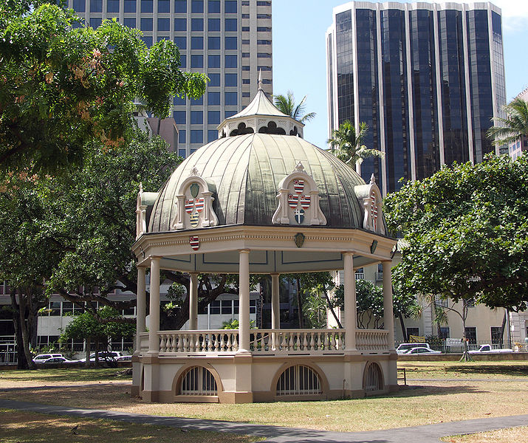
A large gazebo on the grounds of Iolani Palace, Honolulu, Hawaii, USA (figure 6)
- In English-speaking countries, a kiosk is a booth with an open window on one side. Some vendors operate from kiosks, selling small, inexpensive consumables such as newspapers, magazines, lighters, street maps, cigarettes, and confections.
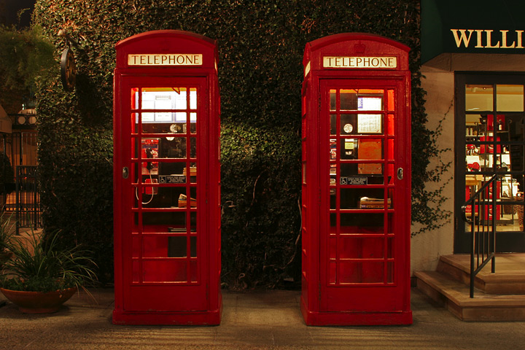

- An information kiosk (or information booth) dispenses free information in the form of maps, pamphlets, and other literature, and/or advice offered by an attendant.
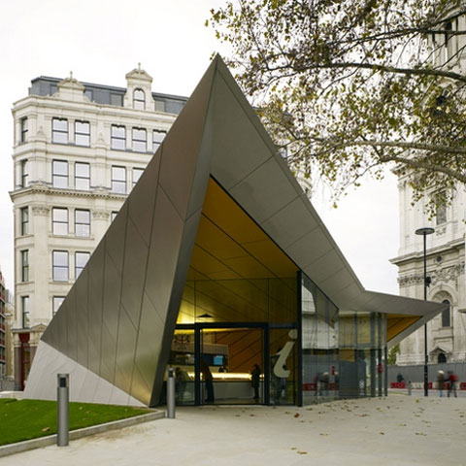

- An electronic kiosk (computer kiosk or interactive kiosk) houses a computer terminal that often employs custom kiosk software designed to function flawlessly while preventing users from accessing system functions. Indeed, kiosk mode is a euphemism for such a mode of software operation. Computerized kiosks may store data locally, or retrieve it from a computer network. Some computer kiosks provide a free, informational public service, while others serve a commercial purpose. Touchscreens, trackballs, computer keyboards, and pushbuttons are all typical input devices for interactive computer kiosk.
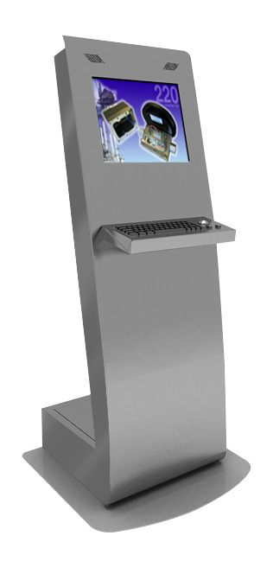

- An art kiosk?

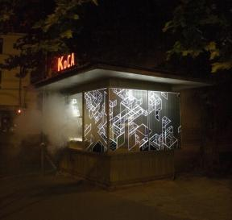

References
Felsefe Ekibi (2008) http://www.felsefeekibi.com/sanat/sanatalanlari/sanat_alanlari_anadolu_selcuklu_mimarisi_kervansaraylar.html )
http://www.aksaraykulturturizm.gov.tr/BelgeGoster.aspx?F6E10F8892433CFF64C9C7E66308B19B5254F1D0910D5730
http://www.metu.edu.tr/home/wwwissch/ozgurey/kayseri/sultana
ks.htm

Frischmann, M., Asad, M., (1994), The mosque : history, architectural development & regional diversity, Thames and Hudson, London

Peker, A.U., (2001) Anadolu Selcuklulari’nin Anitsal Mimarisi Uzerine Kozmoloji Temelli Bir Anlam Arastirmasi. Istanbul Technical University unpublished Ph D. dissertation.

http://www.transanatolie.com/English/Turkey/Turks/Selcuks/seljuks_&_architecture.htm

Peker, A.U., (2003) Radikal 2, Tarihsel mimarlık ve çevre

http://www.radikal.com.tr/ek_haber.php?ek=r2&haberno=2656

Wikipedia, kiosk

Wolfgang, V., (2008), Die Moschee von Sinan, Wasmuth, Thubingen.

